MACT 4212: Stochastic Processes

Assignment 2

Instructor: Noha Youssef

Fall 2024

**Question 1**

Consider the following Markov chain with state space{1, 2, 3} and transition matrix and Find:

1. *P*[*X*2 = 2|*X*0 = 1].
2. *P*[*X3* = 2|*X*0 = 1, *X*2 = 1].
3. *P*[*X*1 = 2|*X*2 = 1].
4. *P*[*X*2 = 3] given that $π^{T}=\left[0.2 0.3 0.5\right]$

$$P^{2}=P*P=\left(\begin{matrix}0.44 & 0.16 & 0.4 \\ 0.225 & 0.525 & 0.25 \\ 0.3 & 0.325 & 0.375\end{matrix}\right)$$

$$π^{T}*P^{2}=\left[\begin{matrix}0.3055 & 0.352 & 0.3425\end{matrix}\right]$$

$$P\left[X_{2}=3\right]=0.3425$$

**Question 2**

Three white and three black balls are distributed equally into two urns. We say that the system is in state *i*, *i* = 0,1,2,3, if the first urn contains 3 white balls. At each step, we draw one ball from each urn and exchange them. Let *Xn* denote the state of the system after the *n*-th step. Find the transition probability matrix.

This is a Markov chain where the system’s state is specified by the number of white balls in the first urn.

There are four states:

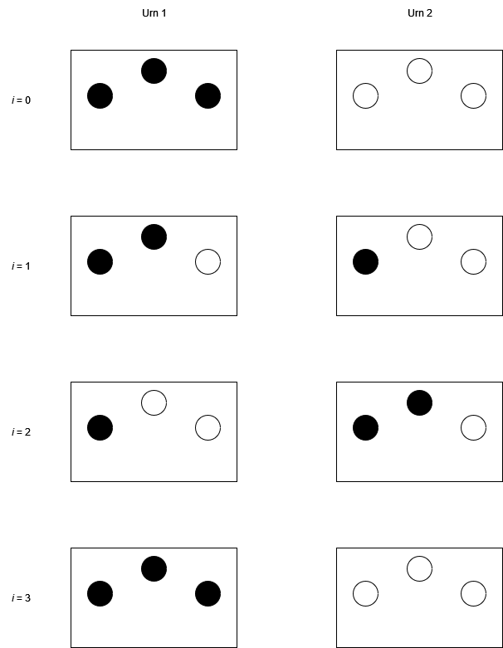

The diagram above shows both urns with the one on the left being the first urn in which we count the balls.

According to the problem statement, we can say that this is a Discrete-Time Markov Chain (DTMC). The probability of the next state is dependent only on the current state. If we are in a state, it does not matter how we arrived at that state.

For instance,

$$P\left[X_{n+1}=2 | X_{n}=2\right]=\frac{4}{9}$$

Since we need to choose either of the white balls with a probability of 2/3 in the first urn and the white ball in the second urn with a probability of 1/3 or either of the black balls in the second urn with a probability of 2/3 and the black ball in the first urn with a probability of 1/3. Events are independent. It is impossible for the system to remain in state 3. If the system is in state 3, it is certainly going to transition to state 2.

$$P\left[X_{n+1}=0 | X_{n}=0\right]=0$$

$$P\left[X_{n+1}=1 | X_{n}=0\right]=1$$

$$P\left[X_{n+1}=2 | X_{n}=0\right]=0$$

$$P\left[X_{n+1}=3 | X_{n}=0\right]=0$$

$$P\left[X_{n+1}=0 | X_{n}=1\right]=\frac{1}{9}$$

$$P\left[X_{n+1}=1 | X_{n}=1\right]=\frac{4}{9}$$

$$P\left[X_{n+1}=2 | X_{n}=1\right]=\frac{4}{9}$$

$$P\left[X_{n+1}=3 | X_{n}=1\right]=0$$

$$P\left[X_{n+1}=0 | X_{n}=2\right]=0$$

$$P\left[X_{n+1}=1 | X_{n}=2\right]=\frac{4}{9}$$

$$P\left[X_{n+1}=2 | X_{n}=2\right]=\frac{4}{9}$$

$$P\left[X_{n+1}=3 | X_{n}=2\right]=\frac{1}{9}$$

$$P\left[X_{n+1}=0 | X_{n}=3\right]=0$$

$$P\left[X_{n+1}=1 | X_{n}=3\right]=0$$

$$P\left[X_{n+1}=2 | X_{n}=3\right]=1$$

$$P\left[X_{n+1}=3 | X_{n}=3\right]=0$$

$$P=\left(\begin{matrix}0 & 1 & 0 & 0 \\ \frac{1}{9} & \frac{4}{9} & \frac{4}{9} & 0 \\ 0 & \frac{4}{9} & \frac{4}{9} & \frac{1}{9} \\ 0 & 0 & 1 & 0\end{matrix}\right)$$

**Question 3: R application**

Open the R code attached, modify and run the code to answer the following questions

1. Draw the transition diagram in question 1 using the R code provided. Label the states as 1, 2, and 3.

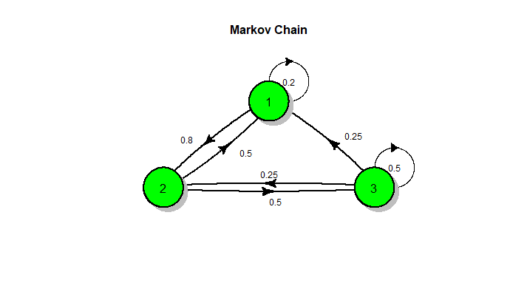

1. Find *P*(*X*4 = 2|*X*0 = 1) using the R code.